**Asian School of management and technology**

**(Affiliated to Tribhuwan University)**

**Gongabu,Kathmandu**



**Project Report On “REGISTRATION SYSTEM”**

**For**

**Software Project Management(CSC 415)**

**7th semester Project Report submitted in the partial fulfillment of the requirements for the degree of Bachelor of Science in Computer Science and Information Technology**

**Submitted By: Submitted To:-**

**Dikshya Karki (20988/075) Surya Bam Sir**

**Anisha Lammichane(20982/075)**

**Bimala Gadtaula(20987/075)**

**Sajita Thapa (21008/075)**



# CERTIFICATE OF APPROVAL

The undersigned certify that they have read and recommended to the respective subject teacher and external teacher for acceptance, a project report entitled **“**“**Registration System**”**”** submitted by **Dikshya Karki, Anisha Lammichane, Sajita Thapa,Bimala Gadtaula** for the partial fulfillment of the requirement for the degree of Bachelor of Science in Computer Science and Information Technology.

….…………………………..

External Examiner

Tribhuvan University

# 

# ACKNOWLEDGEMENT

We would like to express our deepest appreciation to all those who provided us the possibility to complete this report. A special gratitude we give to our final year project Supervisor, Mr. Surya Bam Sir, in whose contribution stimulating suggestions and encouragement, helped us to coordinate our project especially in writing this report. Furthermore, we would also like to acknowledge with much appreciation the crucial role of the staff of Asian School of Management and Technology, who gave the permission to use all required equipment and the necessary materials to complete the task. We are thankful and fortunate enough to get constant support from our seniors and every teaching staff of B.Sc. CSIT department which helped us successfully complete our project. We would also like to extend our regards to all the non-teaching staff of B.Sc. CSIT department for their timely support. We have to appreciate the guidance given by other supervisors as well as the panels especially in our project presentation that has improved our presentation skills thanks to their comments and advice. Our thanks and appreciations also go to each and every one of our colleagues for their encouragement and support in developing the project.

With respect,

Anisha Lamichhane

Bimala Gadtaula

Sajita Thapa

Dikshya Karki

# ABSTRACT

“Registration System” is a web-based platform that provides the Nepalese Citizens an interactive platform for government-related tasks performed in respective District Administration Office or Ward Office for Birth and Death registration and replaces this work with an online platform. Today developing countries have been facing problems in birth and death certificates processing and their records management which has always resulted from excessive corruption, poor security, inappropriate records management criteria and forgery especially by aging government employees who are always struggling to secure their job positions before retiring. In addition, the same problem has been experienced in the government employees who utilize the weaknesses in the current manual way of document handling, to keep on falsifying about their true age in the office of the registrar general. This has been as a result of the registrar general’s office failure to embrace information technology to help them redesign their business processes by automating some of their operation procedures. Most low developing countries are facing a number of problems in birth and death certificates processing and production these include; bureaucracy, bribery, corruption, forgery, security and poor records management which is currently done manually. This makes the processing of documents slow and more hectic. Therefore the government of needs to come up with an automated birth and death certificates records management system to help reduce these problems through embracing information and communication technology (ICT).

# ABBREVIATIONS

CSS: Cascading Style Sheets

DFD: Data Flow Diagram

ER: Entity Relationship

HTML: Hypertext Markup Language

IDE: Integrated Development Environment

IIS: Internet Information Services

IT: Information Technology

**Table of Content**

Table of Contents

ACKNOWLEDGEMENT 1

ABSTRACT 2

ABBREVIATIONS 3

CHAPTER 1: INTRODUCTION 7

1.1 Introduction 7

1.2 Problem Statement 7

1.3 Objectives 7

1.4 Scope and Limitations 8

1.5 Report Organization 8

CHAPTER 2: LITERATURE REVIEW 9

2.1 Literature Review 9

CHAPTER 3: SYSTEM ANALYSIS 9

3.1 Requirement Analysis 9

3.3 Data Model: 11

3.4 Process Model 12

CHAPTER 4: SYSTEM DESIGN 13

4.1 System Architecture 13

4.2 Interface Design 13

4.3 Form and report design 14

4.4Flow Chart 16

CHAPTER 5: IMPLEMENTATION AND TESTING 18

5.1 Implementation: 18

5.2 Implementation Module 18

CHAPTER 6: Conclusion and Recommendation 19

6.1 Conclusion 19

6.2 Recommendation 19

6.3 Future Works 19

References 20

**List of Figures**

1. UML Diagram
2. Class Diagram
3. DFD 0 level Diagram
4. DFD 1 level Diagram
5. System Architecture
6. Interface of the System
7. Birth Registration Form
8. Death Registration Form
9. National Id Registration form
10. Dataflow diagram

## CHAPTER 1: INTRODUCTION

### 1.1 Introduction

A Registration System eliminates the need of filling paper forms manually and sending them to a registration office. When using online registration systems, the participants can simply register at their convenience and submit their information immediately. The system includes birth registration and death registration. Birth Registration is a fundamental right of all children and a basic function of all modern governments. Promoting children right to birth registration falls clearly within UNICEF mandate. Birth Registration comprises two elements: entering details of a child’s birth into official government records, and issuing a birth certificate to the child’s parents, including information on the parents’ names, date and place of birth and further information such as nationality. There has been some progress, though small in raising birth registration levels. Death registration includes the number of deaths occur among certain age group in different cities.

### 1.2 Problem Statement

Most low developing countries are facing a number of problems in birth and death certificates processing and these include; Bureaucracy, bribery, corruption, forgery, security and poor records management. This makes the processing of documents slow and more hectic hence the government of Uganda needs to come up with an automated birth and death certificates records management system to help reduce these problems through embracing Information and Communication Technology (ICT).

### 1.3 Objectives

The major objectives of this project are listed below:

● To simplify the registering process of general citizen’s birth and death events.

● To assign the registration specific certificate on request.

● To allow admin to upload and manage the entire details regarding the citizen.

● To allow citizens to view and download their specified certificates.

● To allow the admin (IT officer) and citizen to view and upload various notices and opinions as well as to participate in polls.

### 1.4 Scope and Limitations

#### 1.4.1 Scope

** Time Management**: we can access services quickly without any delay until and unless some network issues.

** Cost-effective:** No need to travel to a physical location to get the work done. We can get our work completed in small time without traveling. Instead, the same service can be accessed at a much lower cost than usual.

** Transparency:** With the digitization of every piece of work and process, there is no place left for corruption or any biases. There is equality and a good relationship with every citizen.

** Flexibility:** It is much easier to inform a bunch of citizens of new projects, problems as well as services.

#### 1.4.2 Limitation

**(i)Time:** Time was a big constraint for this project trying to meet deadlines was not easy as changes to the project had to be made at various times.

**ii) Software:** Software plays a big factor in the final outcome of the project therefore getting the right ones was vital and also incorporating them into the project.

**iii) Availability of personnel**: Getting held of employees to ask questions about the Organization was next to impossible at times.

**Iv) Finance:** Getting the finances for transport to meet up for discussions was difficult.

### 1.5 Report Organization

In chapter2, we talk about the feasibility study that is needed for constructing the system and structuring system requirements i.e. process modeling and also a Use case diagram.

Chapter 3 includes the system design, i.e. the architecture of the system, input-output definition, and the user interfaces. Implementation i.e. User Implementation and Login implementation with testing and the MVC implementation of the system is described in chapter 4. In conclusion, enhancement of the system that can be made in the future is included in the fifth.

## CHAPTER 2: LITERATURE REVIEW

### 2.1 Literature Review

Almost all registration activities of Nepal are mostly manual and online registration is being introduced in recent years. All municipal work like birth registration, death registration, publishing the notice of upcoming events, applying for complaints, birth, death, and other certificates are done manually. There is little practice of online sites for accomplishing these tasks. Digitization of paper-based documents is an approach to make a digitized government office.

[1]Among available form of online registration platforms, most of them are third party website which lacks integrity, confidentiality, and availability. Some of them are the Department of National Id and Civil, Online Vital Registration.

[2]. There are few government official online municipal sites that provide the facility of online registration for birth, death, marriage, and divorce. E.g. Gokarneshwor Municipality.

[3]. It is one of the reliable government-owned sites. This site provides full information regarding upcoming government notice about projects, offers, etc. as well as programs, electrical suspension, contact, reconstruction updates.

## CHAPTER 3: SYSTEM ANALYSIS

### 3.1 Requirement Analysis

Requirement analysis is the phase where the system is built based on its functional and non-functional requirements which describes how the overall system works and what functional characters it delivers. The system describes the overall workings and enlists the requirements of the overall project. In addition, a use case diagram also shows the overall procedure of the system. This overall working of the system and derive the requirements, detailed and thorough understanding of the system to be developed or being developed is needed. This understanding is developed by continuous coordination with the project team members.

#### 3.1.1 Functional Requirements

The functional requirement should show how the system should react to the inputs and what set of desired output is obtained from the input. These requirements are according to the user i.e. how the system should operate and what output must be generated with the given set of inputs.

**What does the system do?**

• Only government employees (admin) can view the details.

• Registration for the national id.

• Registration form for both birth and death registration.

• Allow the Government employees (the admin) to verify the certificate.

• Once registered all the info goes to the local government.

• Details up to date easily.

**What does not the system do?**

• General public cannot view the details about the municipality.

#### 3.1.1.1 Use Case Diagram

A use case diagram at its simplest is a representation of a user&#39;s interaction with the system that shows the relationship between the user and the different use cases in which the user is involved.

### 3.3 Data Model:

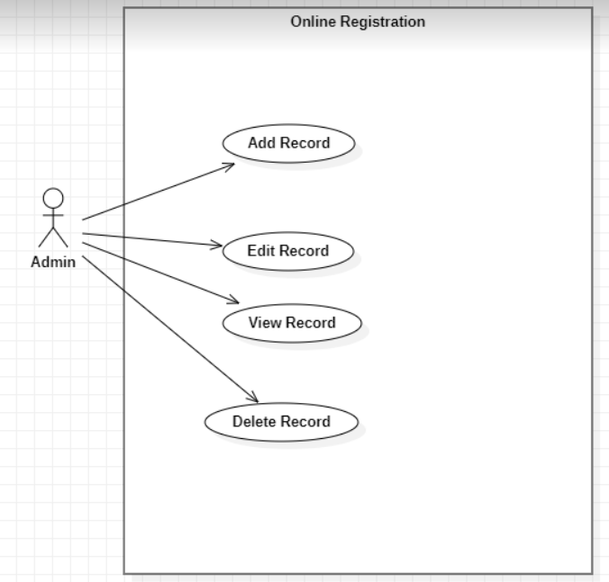

##### Fig- UML diagram

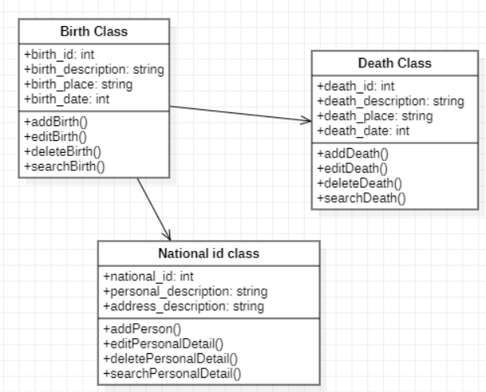

##### Fig- Class diagram

### 3.4 Process Model

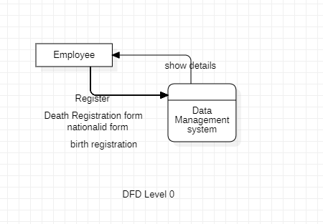

##### Fig- 0-level DFD diagram

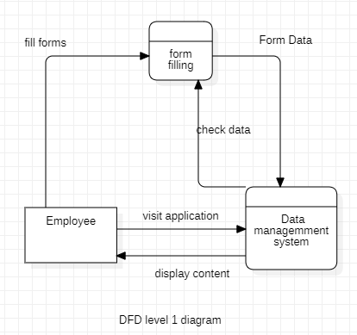

##### Fig-1-level DFD diagram

## CHAPTER 4: SYSTEM DESIGN

### 4.1 System Architecture

“Online Registration” is a web-based system for Municipality Bodies. The system is the web interface for a combination of Certificate Management System and Information Management System. The system takes user and admin logins. Admin can perform a variety of tasks in the admin panel. Admin, for instance, can register citizens and also register citizen’s records to generate the particular certificate. The system works efficiently.

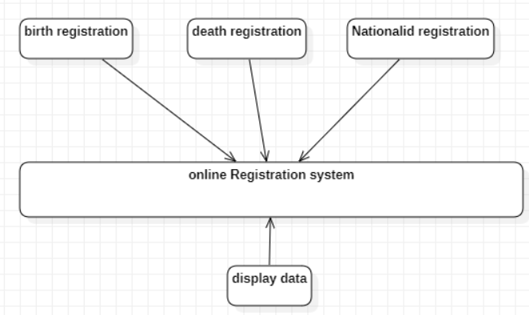

##### Fig- System Architecture

### 4.2 Interface Design

With the help of scripting languages like JavaScript and Markup language like HTML and styling with CSS, the front end of the software is designed to show the overall design of the system. The Interface design contains a home page that gives a brief layout of the system and also contains a login system for users and admin. The home tab on the interface gives details of all the services users can get from the system.

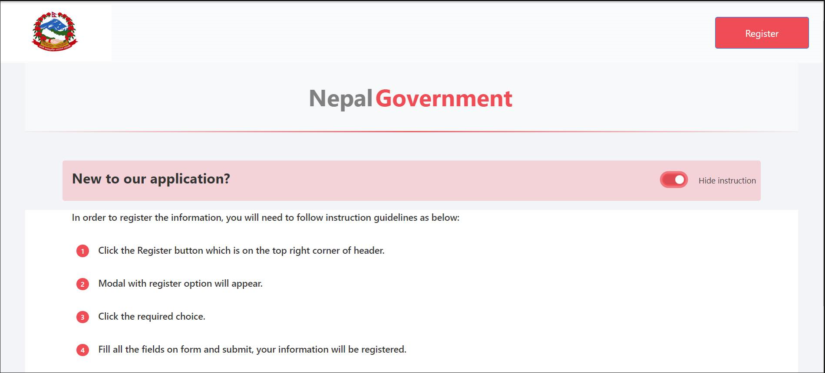

Fig- Interface of the system

### 4.3 Form and report design

The design element for the form is done in HTML, CSS, and JS. The birth Registration form and Death registration form are two forms for general users.

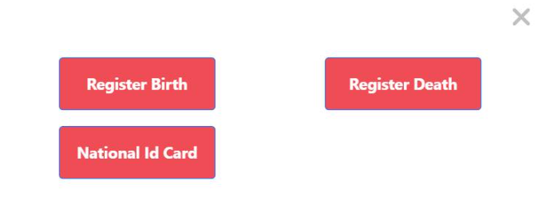Fig

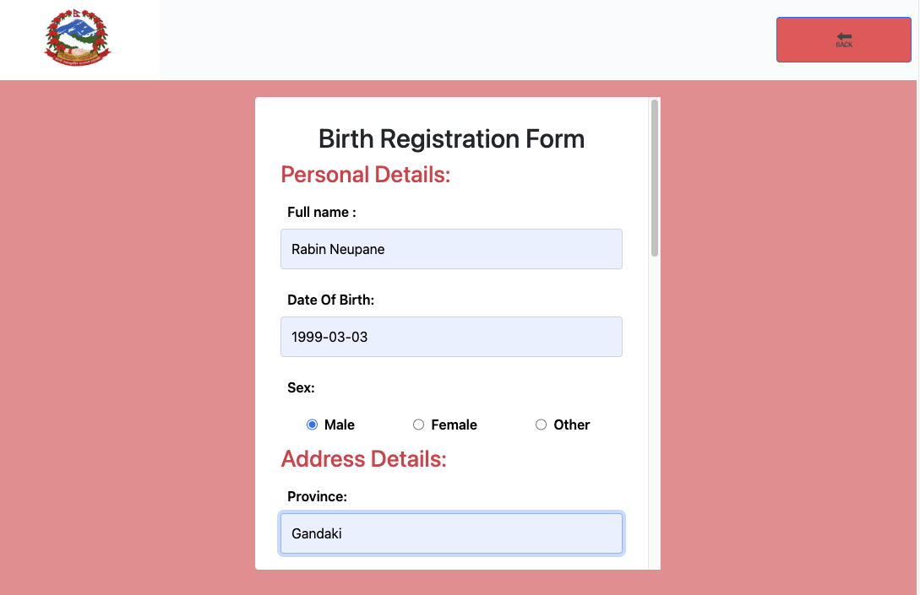

##### Fig- Birth registration form

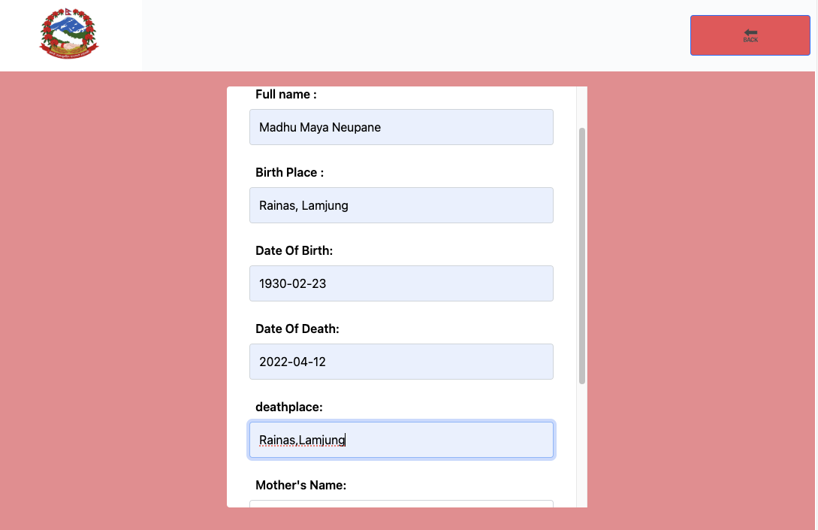

Fig-Death registration form

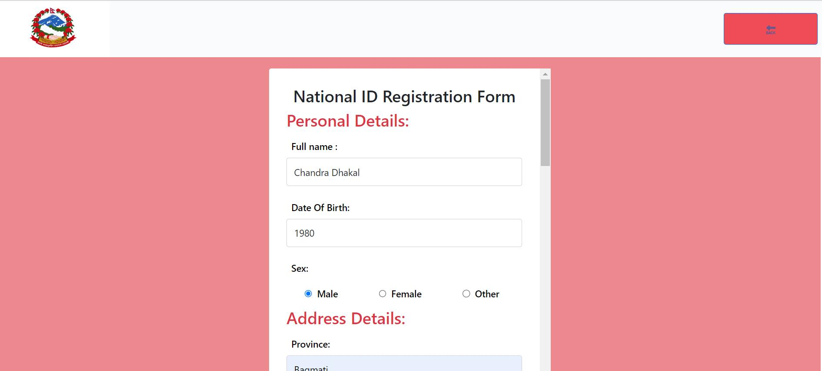

##### Fig- National Id registration form

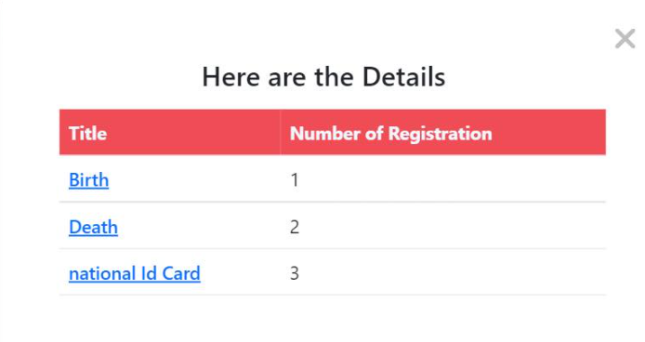

### 4.4Flow Chart

The Flow chart explains the overall workflow of the system:

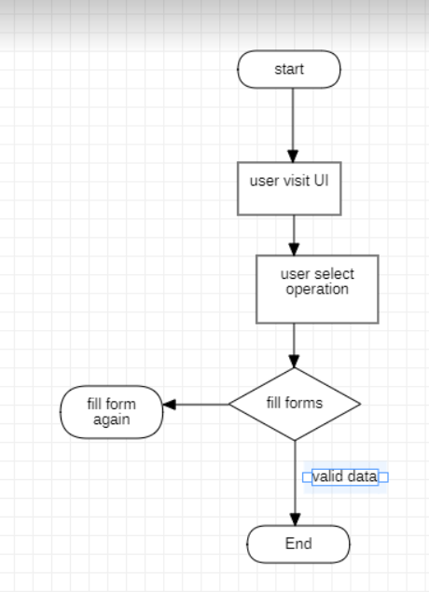

##### Fig-Dataflow diagram

## CHAPTER 5: IMPLEMENTATION AND TESTING

### 5.1 Implementation:

The web-based system is implemented for municipalities. User details were taken as form input. Then the detail was validated on the client-side before further processing. After completing this, the certificate is generated on the admin side.

#### 5.1.1 Admin Implementation

Admin has all the access to the system internal and external working of the system. Registering new citizen’s record to a particular certificate form, admin possesses the authority to do so. In addition, the admin provides certificates of the particular user who has registered at that place .Updating notices to any information, the admin only has the privilege to do so. Admin on the other hand has the authority over the overall system.

### 5.2 Implementation Module

#### 5.2.1 Layout Module:

This module defines the layout of the system. A layout is a component that is set on the interface no matter the operation or the task.

#### 5.2.2 Home module:

This module displays the home page. This is the first page the user sees when he/she first visits the site. From this page, the user can then access for further operation.

#### 5.2.3 Authentication Module:

In this module, the authentication for admin occurs. In this module, the system asks the individual whether the individual is an admin or not. Once the admin is authenticated, the admin can create a new piece of information or edit the existing information.

#### 5.2.3.1 Display Model:

The display model displays the content of the database in the interface.

5.3.1 Front end Tools: The front-end tools were used to enhance the interface and make it attractive and user friendly. The list of front-end tools used are:

• Html (used to create the structure of the web page i.e. content of web page)

• CSS (used to design the pages)

• JavaScript (used to implement function)

## CHAPTER 6: Conclusion and Recommendation

### 6.1 Conclusion

The major intention of this project is to develop a system where a citizen can register for birth, death and national identity card registration certificates through an online platform Online Registration. Doing these, the system would decrease the time required for the general public to get general information, form format, as well as death and birth certificate in the case of urgency and for better convenience. In addition, there is no biasedness in service delivery. Since the start of the project, we researched and develop a system with the main objective of providing birth and death certificates with other vital functionalities.. As per our plan, we developed a system that could operate as we have expected .However, we did not cover the most of functionalities as much as we have wanted. Our system can successfully can register birth, death and national identity card certificates.

### 6.2 Recommendation

This application can always be improved no matter how hard we have tried to make it as we have expected. In our application, we have only allowed a user to register for the birth, death and national identity card registration without any further additional functionalities and proper security. To improve further, we can add an authentication system for the user. In addition to this, we have only focused on the general function. The system focuses more on the user panel. Furthermore, we can add some more controller and model classes with views to generate more services in the user panel for general citizens. This makes the system more flexible, modular, and manageable in the long run.

### 6.3 Future Works

. In our case, we will focus on a platform where users can access most of government official information and certification management performance. However, it can be further implemented on other tasks where the citizen’s opinion analysis and demonstration.as well as, we can improve on upcoming projects to increase work proficiency.

## References

[1] “Digitization,” [Online]. Available:

<http://digitization.docr.gov.np/Account/Login?ReturnUrl=%2F>.

[2] “Online Vital Registration,” [Online].

Available: <https://mis.donidcr.gov.np/>.

[3] Gokerneshwor. [Online]. Available: <https://www.gokarneshwormun.gov.np/en>.

[4] M. Martin, “Guru99,” [Online]. Available: https://www.guru99.com/mvctutorial.html.